
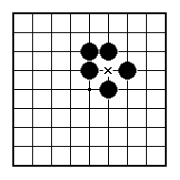
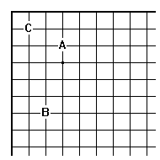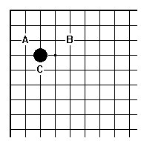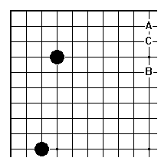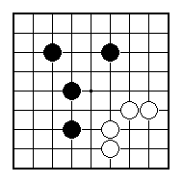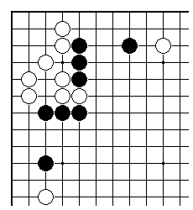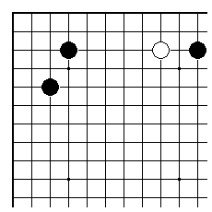
Which of A, B or C would be a good first move?

Which of A, B or C would be best for White?

Which of A, B or C would be best for White?

Who has the better position?

White to play.

Where is it best to play for Black? Or for White?

NAME:
BRITISH GO ASSOCIATION CERTIFICATE LEVEL 3 - SHEET 1

OPENING IDEAS

